Point Sources, Water Withdraws, and On-site Waste Disposal Systems

7.1 Introduction
This section describes development of the point source input for the Phase 5 Model including a description of the data sources, methods, and assumptions. The point source data covers the 1984 to 2005 time frame and is updated annually as data becomes available. Water withdraws for water supply or other consumptive uses, and on-site wastewater disposal systems (OSWDS) are also documented in this section.

The Phase 5 Watershed Model point source database includes information for about 815 industrial, municipal, and federal facilities discharging directly to the surface waters within the Chesapeake Bay watershed. The exact number of dischargers change from year to year as new facilities are added and old facilities closed. Dischargers in the Chesapeake watershed are included from portions of the States of New York, Pennsylvania, and West Virginia, as well as the entire States of Maryland, Delaware, Virginia and the District of Columbia. For each facility outfall, the database includes monthly flow and monthly average concentrations for total nitrogen (TN), ammonia (NH₃), nitrate and nitrite (NO₂+NO₃), total organic nitrogen (TON), total phosphorus (TP), orthophosphate (PO₄), total organic phosphorus (TOP), total suspended solids (TSS), biological oxygen demand (BOD₅), and dissolved oxygen (DO). The point source data covers the 1984 to 2005 timeframe and is updated annually as data becomes available. The record of point source discharges for the Phase 5 domain outside the Chesapeake watershed were generated by the Richmond USGS using the same decision rules as the point sources within the Chesapeake watershed and the data only extends from 1984 to 2003.

In the Phase 5 Watershed Model, the river segments are simulated as a completely mixed reactor and all of the point source loads with in a reach are summed for each of the 1,063 river segments and input as a daily load.

The complete time series of information on point source discharges as applied in the Phase 5 river-segments from 1985 to 2005 can be found at the Chesapeake Community Modeling Program’s (CCMP) Phase 5 data library located on the web at:
http://ches.communitymodeling.org/models/CBPhase5/datalibrary.php

7.2 Point Source Flows and Loads
From 1984 to 2005, point source flows have increased overall throughout the Chesapeake watershed. In contrast, point source loads have generally decreased because of increased point source management and controls. Figures 7.1, 7.2, and 7.3 show the increase in total Chesapeake point source flow, nitrogen load, and phosphorus load. Flow for the nine major basins is shown in Figures 7.4a to 7.4i and equivalent plots are shown for the nitrogen and phosphorus loads in Figures 7.5a to 7.5i and 7.6a to 7.6i, respectively. Monthly data parameters of the point source database are listed in Table 7.1.
Figure 7.1 should be total flow for the Chesapeake watershed, but it’s not. We need to correct this in the next version of Section 7
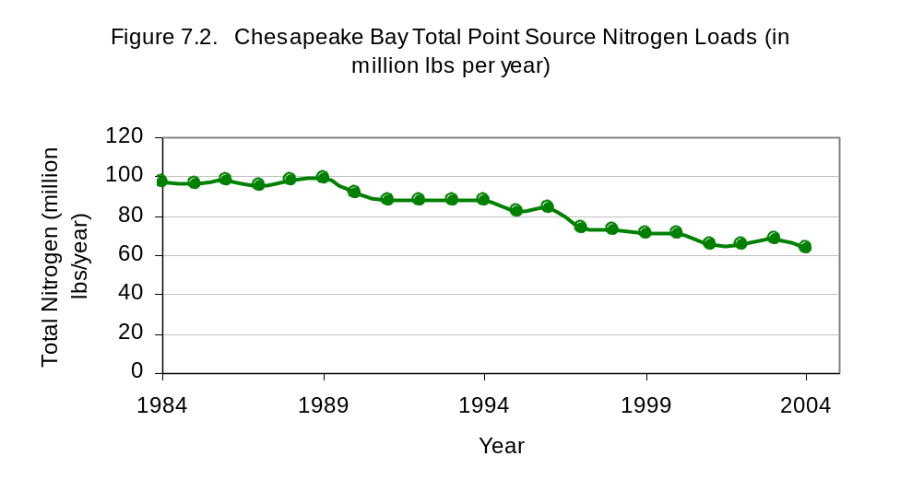
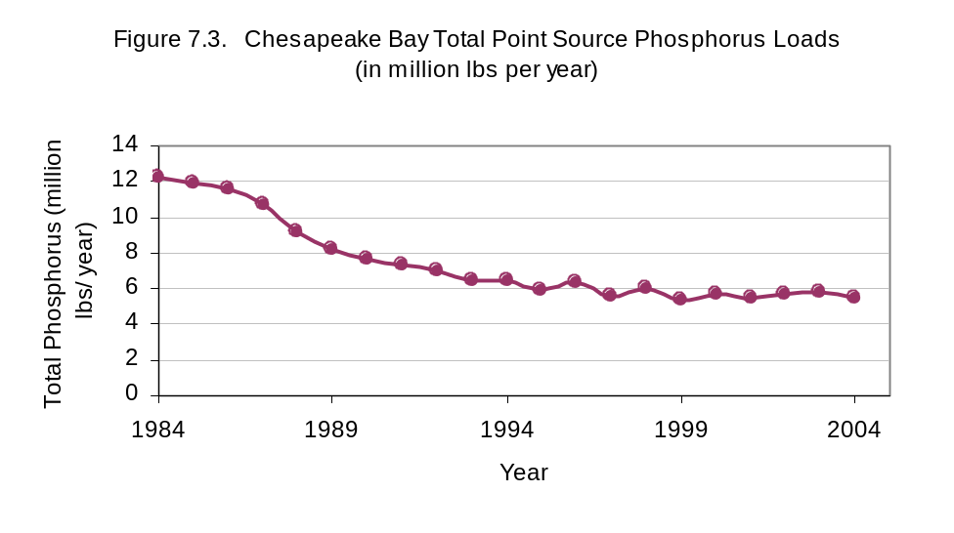
Table 7.1. Parameters included in the point source database
Parameter | Units
Parameter | Database | Phase 5 input
Flow | Million gallons per day (mgd) | Million gallons per day (mgd)
Total Nitrogen (TN) | mg/l | lbs/day
Ammonia Nitrogen (NH₃) | mg/l | lbs/day
Nitrate-Nitrite Nitrogen (NO_{2,3}) | mg/l | lbs/day
Total Organic Nitrogen (TON) | mg/l | lbs/day
Total Kjeldahl Nitrogen (TKN) | mg/l | lbs/day
Total Phosphorus (TP) | mg/l | lbs/day
Phosphate (PO₄) | mg/l | lbs/day
Total Organic Phosphorus (TOP) | mg/l | lbs/day
Biochemical Oxygen Demand (BOD₅) | mg/l | lbs/day
Dissolved Oxygen (DO) | mg/l | lbs/day
Total Suspended Solid (TSS) | mg/l | lbs/day
On the basis of minimum flow rates, major and minor municipal and industrial dischargers were grouped separately in the early 1990s by each jurisdiction. These two groups of dischargers are the basis for differences in annual progress reporting in the CBP. Jurisdictions were encouraged, but not required, to provide flow and concentration data for non-significant facilities that had discharge rates below the minimum flow rate, usually 0.4 million gallons per day (mgd).
Note: The term non-significant is defined by a minimum flow and does not imply any quantification of importance to water quality. To avoid confusion over the term, the acronym NSF for Non-Significant Facilities will be used in subsequent text.
Almost all of the NSF information was incorporated into the Phase 5 point source input files. However, the information on NSFs is generally not as well characterized as the major dischargers. Most of the NSFs load estimates were developed through a special study of these loads in 2008.

7.2.1 Major and NSF Dischargers
A major discharger, also called a significant discharger, is a facility that meets one of the following criteria:
• In West Virginia, Delaware, and New York—Facility treating domestic wastewater and the design flow is greater than or equal to 0.4 mgd.
• In Pennsylvania—Facility treating domestic wastewater and discharging greater than or equal to 0.4 mgd.
• In Maryland—Facility treating domestic wastewater and the design flow is greater than or equal to 0.5 mgd.
• In Virginia—Facility treating domestic wastewater and the existing design flow is greater than or equal to 0.5 mgd west of the fall line or 0.1 mgd east of the fall line. (If adopted, the draft point source permitting regulations in Virginia would redefine all new facilities greater than 40,000 gallons per day (gpd) or facilities expanding by greater than 40,000 gpd as significant.)
• Industrial facilities with a nutrient load equivalent to 3,800 TP lbs/year or 27,000 TN lbs/year.
• Any other municipal and industrial facilities identified within a jurisdictional Tributary Strategy.
Table 7.2 summarizes the number of current, active significant facilities in each jurisdiction. There are 468 significant facilities reported in the database (Figure 7.7).
Table 7.2. Significant point sources in the Chesapeake Bay Watershed (as of May 2006)
Jurisdiction | Number of facilities
Jurisdiction | Municipal |  | Industrial |  | Total
Jurisdiction | Nonfederal | Federal | Nonfederal | Federal | Total
Virginia | 99 | 3 | 22 | 0 | 124
Pennsylvania | 175 | 1 | 24 | 1 | 201
Maryland | 69 | 6 | 9 | 0 | 84
DC | 1 | 0 | 0 | 0 | 1
New York | 26 | 0 | 2 | 0 | 28
Delaware | 3 | 0 | 1 | 0 | 4
West Virginia | 10 | 0 | 15 | 1 | 26
Total | 383 | 10 | 73 | 2 | 468
Note: Federal dischargers are point sources associated with federal lands, such as a military bases, and fall under different point source discharge permitting and management.

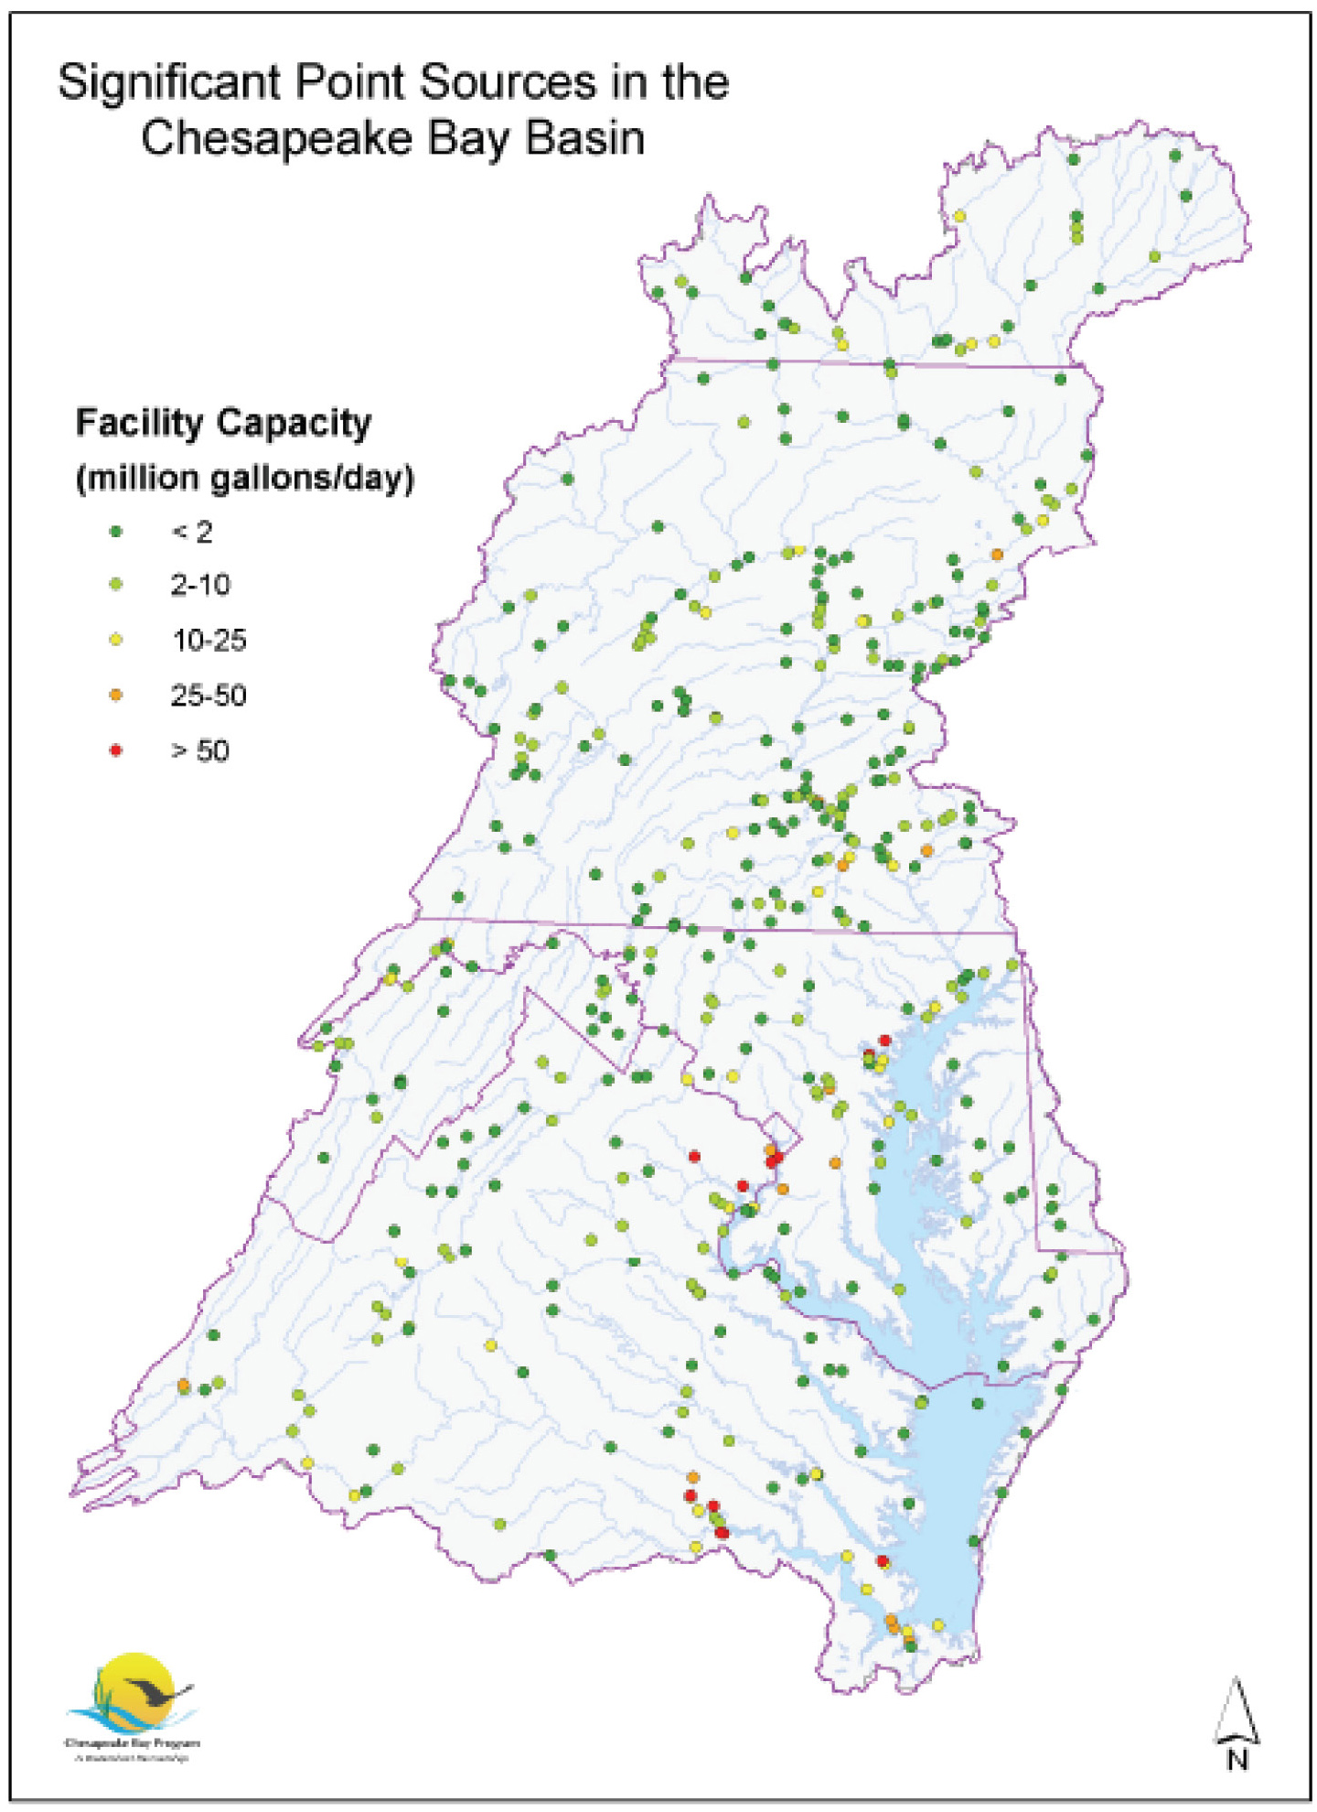
Figure 7.7. Map of major and minor point sources in the Chesapeake watershed.

In addition to pollutant and flow parameters, listed in Table 7.1, descriptive information about each facility including information such as facility name, National Pollution Discharge Elimination System (NPDES) permit number, location (latitude, longitude, county, state, and basin), and facility type (industrial, municipal, or federal) are tabulated in the following database. (HOTLINK HERE TO CBPO POINT SOURCE DATA BASE).
The significance of missing point sources less than 0.4 mgd and other small dischargers

Tables 7.3, 7.4, and 7.5 compare the flows and loads between significant and non-significant plants for a sample year, 2006. (Blue Plains flow and loads are listed for DC and not allocated among DC, VA and MD.)

Table 7.3. Flows of NSF and major facilities in the Chesapeake watershed in 2006.
2006 Annual Flow
STATE | NFS | Major | Total | % NSF
DC | 8.90 | 308.22 | 317.12 | 2.81%
DE | 0.03 | 36.15 | 36.18 | 0.09%
MD | 8.62 | 469.20 | 477.81 | 1.80%
NY | 2.16 | 74.01 | 76.17 | 2.84%
PA | 30.19 | 372.12 | 402.30 | 7.50%
VA | 16.34 | 861.87 | 878.21 | 1.86%
WV | 3.04 | 46.91 | 49.95 | 6.09%
Total | 69.27 | 2168.47 | 2237.75 | 3.10%

Table 7.4. Total nitrogen loads of NSF and major facilities in the Chesapeake watershed in 2006.
2006 TN Load
STATE | NFS | Major | Total | % NSF
DC | 130,106 | 5,333,641 | 5,463,748 | 2.38%
DE | 832 | 185,322 | 186,154 | 0.45%
MD | 402,389 | 11,944,278 | 12,346,667 | 3.26%
NY | 118,247 | 3,374,936 | 3,493,183 | 3.39%
PA | 2,556,991 | 14,108,567 | 16,665,558 | 15.34%
VA | 945,832 | 23,678,852 | 24,624,684 | 3.84%
WV | 235,084 | 669,477 | 904,562 | 25.99%
Total | 4,389,481 | 59,295,075 | 63,684,556 | 6.89%

Table 7.5. Total phosphorus loads of NSF and major facilities in the Chesapeake watershed in 2006.
2006 TP Load
STATE | NSF | Major | Total | % NSF
DC | 26,563 | 74,409 | 100,973 | 26.31%
DE | 190 | 11,909 | 12,099 | 1.57%
MD | 66,723 | 689,708 | 756,431 | 8.82%
NY | 18,630 | 471,811 | 490,441 | 3.80%
PA | 404,368 | 1,726,230 | 2,130,598 | 18.98%
VA | 128,277 | 1,804,240 | 1,932,516 | 6.64%
WV | 31,088 | 416,937 | 448,024 | 6.94%
Total | 675,839 | 5,195,243 | 5,871,083 | 11.51%

7.2.2 Data Sources
The sources of point source information include the following:
• EPA’s Permit Compliance System (PCS), based on state NPDES Discharge Monitoring Reports (DMRs)
• Data files from Pennsylvania Department of Environmental Protection including a 1994 sampling study data and the Pennsylvania Voluntary Monitoring data since 1998
• Data files from the Virginia Department of Environmental Quality based on PCS, DMRs, and the Virginia Voluntary Nutrient Monitoring Program
• Data files from the Metropolitan Washington Council of Governments (MWCOG)
• Combined sewer overflow (CSO) flow and concentration estimates from the District Department of the Environment
• The final tributary strategies from Pennsylvania, Maryland, DC, and Virginia
• Data from the Maryland Department of the Environment
• Data from Delaware Department of Natural Resources and Environmental Control
• Data from West Virginia Department of Environmental Protection
• Data from New York Department of Environmental Conservation
Data source information is documented in USEPA (1998, 2000). Because of a lack of data format consistency among the data received from different jurisdictions and PCS, extensive data compiling was required.

7.2.3 Current Point Source Data Reporting Requirements
As described in the Data Submission Specifications and Requirements (USEPA 2006), for future data submitted for Phase 5 Watershed Model point source database, jurisdictions are required to submit monthly concentration and flow data for all parameters listed below for major discharges.
1. At Facility Level: Data must be provided for those municipal, industrial, and federal facilities as defined above as significant dischargers of TN and TP to the Bay watershed. The jurisdictions must annually update their list of significant dischargers with additional facilities that meet one of the criteria of the significant facility definition. The location (county, latitude/longitude) of each facility’s discharge point must be reported.
2. At the Monthly Level: 12 individual months of concentration and flow data for the nine identified parameters must be provided for each outfall. Jurisdictions will submit all parameters in each month’s data record for each facility. Data for the following parameters will be submitted: average monthly flows and average monthly concentrations of NH₃, TKN, NO₂+NO₃, TN, PO₄, TP, CBOD, and DO. All nitrogen species must be reported as nitrogen; all phosphorus species must be reported as phosphorus.
If there are no monthly monitored concentration data for one or more of the nine parameters for a facility, the jurisdiction will submit the default concentration data or calculated data on the basis the species relationship listed in Table 7.3. All default or calculated data are flagged with explanatory information. Industrial facility data are reported as average monthly flow and concentrations.

7.2.4 Nutrient Species Defaults
The nutrient species calculation must be done for any data record for which nutrient species data was insufficient or missing (Table 7.3).
Table 7.3. Nutrient species default relationships for point source data.
Type of point source |  | NH₃/NO₃/OrgNª  (w/o nitrification) | NH₃/NO₃/OrgN  (w/ nitrification)^{c} | NH₃/NO₃/OrgN  (w/ denitrification)
Municipalities |  | 80/3/17^{b} | 7/80/13^{b} | 12/73/15
Industries | Chemical | 7/85/8+
Industries | Pulp & Paper | 1/0/99^{b}
Industries | Poultry Facilities w/BNR |  |  | 8/75/17^{b}
Industries | Nonchemical (includes seafood, poultry, & food processors w/out BNR) | 80/3/17^{b} | 7/85/8^{d} | 8/75/17^{b}
a - Organic Nitrogen
b - Updated on the basis of an analysis of actual data from plants operating in Virginia.
c - Apply this relationship wherever NH₃ limits apply.
d - Assumed by performing an analysis of MD chemical industry wastewater effluents which showed it is very close to the relationship for nitrifying sewage. This would apply to all chemical discharges and assumes that wastewaters are treated chemically and thus would not vary as for sewage relationships.

Type of point source | Facilities w/out TP reduction  (ortho-phosphate/TP ratio) | Facilities with TP reduction  (ortho-phosphate/TP ratio)
All | 71/29e | 67/33e
e - Determined by averaging the actual data from MD and VA plants (including Blue Plains for with TP Reduction. A facility with TP reduction is defined as a facility having a permit limit for TP.

Period | TSS default (all jurisdictions) | TSS default  w/out NRT | TSS default w/ NRT
1985-1990^{f} | 45
1990-2000 | 25
2000-2010 |  | 15 | 8

Type of point source | DO concentration 1985–1990 | DO concentration 1990–2010
All | 4.5 mg/l ^{f} | 5.0 mg/l
f - Takes into account a number of NMP facilities operating across the watershed

7.2.5 Industrial Flow
Some point source industrial dischargers use river uptake as the only water source. As the facility both withdraws and discharges water in the same model segment, no flow discharge is assumed to come from these industrial facilities. Other industrial point source dischargers use city or well water, or a percentage of city or well water that makes up the total flow discharged. In such cases, the portion of the effluent from the city or well water source is included as a flow contribution to the river segment (Table 7.4). Other industrial plants not in the survey list were assumed to use 100 percent city or well water.

7.2.6 Combined Sewer Overflows (CSOs)
Data provided by the District Department of the Environment was used for CSO flows and concentrations in the District of Columbia. Combined sewer overflow estimates were determined by simulating the combined sewer system model developed by the D.C. Water and Sewer Authority for the development of the Long Term Control Plan (LTCP) for DC CSOs (DCWASA, 2002). For 1991-2005, CSO flows were based on model simulation of individual rainfall events. The model was not simulated for the period 1985-1990. The 1993 model simulated flows, which represented an average condition, were repeated for that period. Average concentrations were derived from the average EMC concentrations for CSO overflows taken from monitoring data collected for the LTCP.

Combined sewer overflows are in other cities in the Chesapeake watershed, such as Harrisburg, PA, Cumberland, MD, Richmond, VA, Lynchburg, VA, but information on flow and loads is unavailable for these areas. With information lacking on these load sources, the Phase 5 model includes only DC’s CSO load and flows.
Table 7.4. Industrial flow survey results
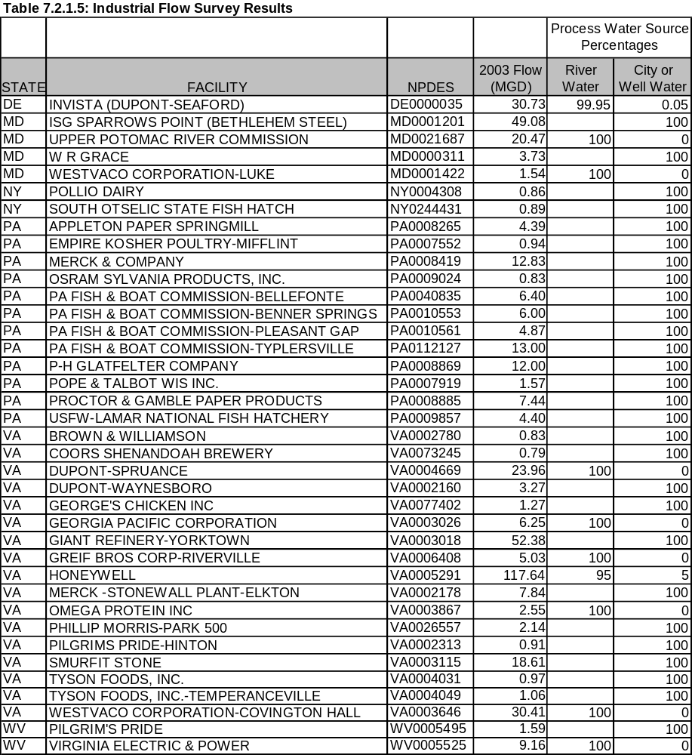

Each jurisdiction reviews all point source data for accuracy and outliers before submission and general quality assurance and quality control requirements are listed in Figure 7.8.
Annual Data Collection
Facility Check: Compare with previous year’s facility list to:

Identify New Facilities: Provide the new facility information to CBPO. Facilities not in the Bay watershed should be excluded.
Look for Missing Facilities: Off-lined or missing data?
Report on new facilities or changes in flow or process
Data search for missing facilities.
Data Check for Each Facility:

Missing Data Check: No discharge, off lined or missing data?
Data Range Check: any data out of normal variation range within the year?
Data Trend Check: is the annual average of TN, TP and FLOW out of normal variation range compared with previous several years’ data?
Report on facilities off-lined during the year.
Data Updating:
Update the data set with corrected and/or verified data
Set the data to zero for the months of no discharge or off-lined.
Use annual average, previous year’s data or default values for verified missing data
Data Compiling For Missing Nutrient Species:
Calculating nitrogen and phosphorous species concentration data from TN, TP or other available species with previous years’ species relationships or different assumptions based on discharge type, NH3 level, de-nitrification and etc. The default nutrient species relationship suggested is described in the following exhibit.
Compiled Data Check
TKN>NH3; TN=TKN+NO23 and TP> PO4
No negative value
No missing data: monthly flow and concentrations for 12 months for each outfall
Final Point Source Data Set
Chesapeake Bay Program Office
Further review if necessary

Figure 7.8. Point source nutrient data processing flow diagram.

7.3 Water Withdrawals
Water-use information for the Phase 5 Model domain has been assembled for simulating withdrawals from respective streams in the different river segments. Daily withdraws are estimated on the basis of reported monthly values in some states or annual values estimated at five year intervals in others. (JING TO PUT TOGETHER A GIS GRAPHIC OF AVERAGE WATER WITHDRAWS BY RIVER SEGMENT - REQUESTED 11/13/08).
The nature of the water-use information depends on the water-use program of the state providing the information. For Maryland and Virginia, information consists of values reported by individual users along with the latitude and longitude of the withdraw. In general, data reported for individual users is expected to be more accurate than estimated values. For New York, Pennsylvania, West Virginia, and North Carolina, water-use information for 1985, 1990, and 1995 were estimated by various techniques and aggregated by eight-digit hydrologic unit codes (HUCs), though better latitude and longitude information was available for consumptive use by thermoelectric withdraws. Information for the year 2000 were estimated in a similar manner but are aggregated by county.
The complete time series of water withdraws as applied in the Phase 5 river-segments from 1985 to 2005 can be found at the Chesapeake Community Modeling Program’s (CCMP) Phase 5 data library located on the web at:
http://ches.communitymodeling.org/models/CBPhase5/datalibrary.php

7.3.1 Types and Timing of Water Withdraws
Withdrawal information was grouped as irrigation use, thermoelectric use, or all other combined uses. Irrigation use is a separate category because of the extreme seasonal cycles in the use. Thermoelectric use is a separate category because individual withdrawals commonly can be many millions of gallons per day, though in once-through thermoelectric cooling, most of the water is discharged back to the source water close to the withdrawal point. A part of the water, however, evaporates, resulting in a consumptive use that can be a significant net withdrawal from a stream.
Withdrawal information was derived from either monthly (Virginia), or annually reported values (Maryland), or from annual values estimated at five year intervals (New York, Pennsylvania, West Virginia, and North Carolina). The availability and accuracy of irrigation use information varies by state and by year. Maryland is the only state with reported irrigation data. In the early 1990s, Maryland passed laws requiring reporting irrigation which were first implemented in 1995.
The accuracy of the five year values used in most states have a higher uncertainty because estimates were derived from procedures selected from the national water-use program which does not necessarily pertain to a Chesapeake watershed state, but these are the best available water withdraw information for much of the Chesapeake watershed.
Withdrawals for many water-use categories vary appreciably by season. Such variations can affect streamflow substantially because many uses are greater during the summer when streamflow approaches annual lows. For example, withdrawals for public water supply typically vary seasonally. For public supplies that provide water primarily for domestic use, withdrawals typically are greatest during the summer because of lawn irrigation, car washing, and similar activities. Peak daily use can be 180 percent of the average annual use (Clark et al. 1971) with the pattern of use largely controlled by temperature and precipitation. For suppliers that provide large water volumes to other users such as industrial users, other seasonal cycles can be superimposed on this cycle. Seasonal cycles in water use other than irrigation, however, remain uncertain and are not estimated.
Irrigation typically occurs during the growing season and increases when evaporation and plant transpiration (evapotranspiration) are high and precipitation is low. The seasonal effects are accounted for by the reported data of Maryland and Virginia but not in the estimated values of the other states. The timing of irrigation varies by crop but typically occurs during summer months. Much of the cropland in the watershed is planted in corn, soybeans, and small grains. Corn typically is planted early in the growing season (May) when evapotranspiration is at moderate levels. The corn typically matures and is no longer irrigated by the end of July. In contrast, soybeans are not planted until later in the growing season and mature in October. Small grains are typically planted in the fall and have little irrigation need. Using these assumptions, the estimated total annual irrigation use was distributed from May through October. Estimated values are daily values averaged over the entire year. These values were multiplied by 12 to give daily values if averaged over a month, and then these values were multiplied by the following fractions to account for the seasonal cycle: 0.1 (May), 0.175 (June), 0.225 (July), 0.225 (August), 0.175 (September), 0.1 (October) and 0.0 (November through April). Should more geographically specific distributions be identified for parts of the watershed, these factors can be modified to better simulate actual conditions.

7.3.2 Consumptive Use
Consumptive use of surface waters is that part of the water that is consumed in manufacturing production or lost by evaporation and therefore not returned to streams. For many large uses, such as cooling water for condensers in thermoelectric generation, little water is consumed and most is returned directly to the streams through permitted wastewater discharges.
Water supply withdraws are a special case of consumptive use. Municipal point source discharges are modeled as flow and load inputs to the appropriate stream segments. These discharges can be to different streams or different stream segments than those from which the water was withdrawn. Consequently, water supply withdraws are modeled as if it were 100 percent consumptive use, with the wastewater modeled separately as return flow through a point source discharge. The net difference between the withdrawal and the discharge is the estimated actual consumptive use. Water-use categories for which the water primarily is returned to streams as permitted discharges include public supply, industrial use, and mining.
Solley et al. (1998) indicate that agricultural irrigation results in 60 percent to 100 percent consumptive use of the water withdraw, but the value is likely to be closer to 100 percent consumptive use throughout the modeled area because either spray or trickle irrigation are used and neither methods return significant amounts of water to streams. Consumptive use by thermoelectric power withdraws are assumed to be 1% of the total withdraw due to evaporation before the water is returned to the river.

New York, Pennsylvania, and West Virginia
Water-use information for these states were limited to annual estimates from the five year compilations by HUC (1985, 1990, and 1995) or by county (2000). Locations for specific withdrawal points were unavailable for any uses except for thermoelectric uses in New York and Pennsylvania. The locations of other withdrawals were determined from maps of the counties, HUCs, cities, and towns. For counties and HUCs having large cities or towns, the withdrawal was assigned to the watershed at the upper end of the city because water-supply withdrawals typically are at the upstream end of a city to reduce the potential for contamination of the supply. For counties and HUCs having small withdrawals because they have no large towns, the withdrawals were assigned to the watershed at the lower end of the county or HUC. In places where boundaries for HUCs and counties did not coincide, the combination of use for the HUCs and counties was compared to help refine the watershed assignment. For example, if a county having substantial use was part of two HUCs and the use was high in one HUC and low in the other, the water use for the county was assigned to a watershed in the part of the county in the HUC having the high rate of use. Because the information consists of annual estimates at five year intervals, the withdrawals for the intervening years were determined by linear interpolation between years having information.

Maryland
Water-use data for Maryland are reported as daily values averaged for the year. These average values are used for every day in that year. Water-use information for Maryland is otherwise processed as indicated above for all states.

Delaware
For the simulated river reaches in Delaware flowing to the Chesapeake, all of which are in the upper reaches of East Shore rivers, diversions are from groundwater only and withdraws from these rivers are absent. There are three Delaware reaches flowing to the Atlantic that are without water diversions because of an oversight in data collection, an oversight that will be corrected in future water-diversion databases as Phase 5 is expanded beyond the 2005 simulation period.

Virginia
Water-use data for Virginia are reported daily values averaged for each month. These average values are used for every day of the respective month. Water-use information for Virginia is otherwise processed as indicated above for all states.

North Carolina
Water-use information for North Carolina is limited to annual estimates from the five year compilations by HUC (1985, 1990, and 1995) and county (2000). Localities in North Carolina have developed water-supply plans that are on the Web page for the North Carolina Department of Environment and Natural Resources. These supply plans give the locations of individual withdrawals so that the appropriate watershed could be assigned to the withdrawals. These plans are for 1997 and 1992 and include water-use values. These water-use values were used as a part of the information and were used to determine ratios among the multiple withdrawals for counties and HUC having multiple withdrawals. Such ratios were applied to the five year estimates to provide estimates of use for each withdrawal. Because the information consists of annual estimates at five year intervals, the withdrawals for the intervening years were determined by linear interpolation.
7.3.3 DC Water Supply and Treatment
The District of Columbia metropolitan region’s drinking water supply is the largest consumptive water withdraw in the Chesapeake watershed. Water treatment consists of withdraw of Potomac River water just above the fall line at Great Falls to the Dalecarlia Reservoir, which acts as a presedimentation basin before final treatment at the Dalecarlia or McMillan water treatment plants (DCWASA 2006). The withdraws at Great Falls are about 5 percent of the average Potomac flow.
The Washington water treatment generates residual solids, a byproduct of producing drinking water, and periodically discharges this material to the Potomac River. The residuals consist of river sediment and solid materials generated by adding coagulant as part of the drinking water treatment process.

Plans for treatment and land disposal of the Dalecarlia Reservoir sludge are underway, and a treatment system is expected to be fully operational in 2010, which will handle on average an estimated 15 truckloads of sludge each day (ABC News 2006).
Until 2010, the residual solids have been discharged to the Potomac River just above the Chain Bridge water quality monitoring station. The episodic discharge plume flows along the Maryland shore and is thought to be largely or entirely absent from the Chain Bridge water quality monitoring data.
Reflecting water treatment practices in the Washington metropolitan region before 2010, the sediment loads estimated from the Dalecarlia Reservoir NPDES records in the CBP point source data base are returned to the Potomac reach just above the fall line (Chain Bridge monitoring station) as a daily load. To get the load of total phosphorus and particulate nitrogen associated with the Dalecarlia Reservoir discharged sediment but unreported in the NPDES record, a regression was formed between TSS and total phosphorus and particulate nitrogen as observed at the Chain Bridge station. This provides a representation of the associated load of phosphorus and particulate nitrogen that would be taken into the Dalecarlia Reservoir presedimentation basin and ultimately associated with the sediment discharged from Dalecarlia. The TSS concentration was found to be somewhat predictive of total phosphorus concentration at the Chain Bridge station with an R² of 0.72 and a low intercept. The weighed average load is 0.0015 mg TP/mg TSS. The TSS concentration was found to be moderately predictive of the particulate nitrogen concentration with an R² of 0.52, a relatively low intercept, and a weighted average load of particulate nitrogen (PN) of 0.007 mg PN/mg TSS. Based on Potomac observations, the particulate nitrogen is assumed to be 11% particulate ammonia and the remainder being particulate organic nitrogen.

Attribution of this load is assumed to be to the jurisdictions of DC, Maryland, and Virginia in the proportion of the ratio of their discharged portions of the Blue Plains flow. In all management scenarios of 2010 and beyond, the loads of sediment and particulate nutrients from this source are assumed to be eliminated, and the three Potomac jurisdictions using this public water supply are credited with the reduction in their Tributary Strategies.

7.4 On-site Wastewater Disposal Systems (OSWDS)
OSWDS, commonly called septic systems, represent an estimated 6 percent of the TN load from the Chesapeake watershed in 2000 (Phase 4.3 Model—Base Scenario). Information of the loads from these systems are generally sparse. Detailed descriptions of data procedures, source information, and assumptions used in estimating these loads can be found in Palace et al. (1998).

Loads from OSWDS are compiled using census data and the methodology suggested in Maizel et al. (1995). OSWDS are simulated as a nitrate load discharged to the river. Phosphorus loads are assumed to be entirely attenuated by the OSWDS. The OSWDS loads are determined through an assessment of the census records of waste disposal systems associated with households. Standard engineering assumptions of per capita nitrogen waste and standard attenuation of nitrogen in the septic systems are applied. Overall, the assumption of a load of 4.0 kg/person-year is used at the edge of the OSWDS field, all in the form of nitrate.
Using an average water flow of 75 gallons/person-day for a septic tank (Salvato 1982), a mean value of 3,940 grams/person-year for groundwater septic flow, 4,240 grams/person-year for surface flow of septic effluent, and typical surface/subsurface splits as reported by Maizel, et al., a TN concentration of about 39 mg/L at the edge of the septic field was calculated. This concentration compares favorably with Salvato (1982) who calculated onsite wastewater management system TN concentrations of 36 mg/L. It is assumed that attenuation of the nitrate loads between the septic system field and the edge-of-river nitrate loads represented in the Phase 5 Model is due to (1) attenuation in anaerobic saturated soils with sufficient organic carbon (Robertson et al. 1991; Robertson and Cherry 1992), (2) attenuation by plant uptake (Brown and Thomas 1978), or (3) attenuation in low-order streams before the simulated river reach. Overall, the total attenuation is assumed to be 60 percent (Palace et al. 1998).
OSWDS loads are input as a daily load in the river reach river. For coastal plain OSWDS loads where there’s no simulated reach, and the OSWDS nitrate loads are delivered directly to the tidal Bay.
Inadequacies in the septic load estimates for model scenario-years occur because the fractions of the population on septic and the number of people per system, used in the Phase 5 Model, are unchanged over time. These assumptions are made because, since 1990, the U.S. Census Bureau survey no longer addresses the number of household served by septic and; therefore, the fraction of the population on septic systems and the number of people per system are unable to be updated through the 1985 to 2005 simulation period of Phase 5. The assumptions of nitrogen attenuation, particularly the assumption of a 60% attenuation between the septic field and the edge-of-river for nitrogen loads applied over the entire Bay watershed may also introduce errors in the estimation of septic loads.

References
ABC News. 2006. Sludge from DC reservoir will be trucked away. Washington, DC. December 12, 2006, 8:41 a.m. Television broadast.
Brown, K.W., and J.C. Thomas. 1978. Uptake of N by grass from septic fields in three soils. Agronomy Journal 70:1037–1040.
Clark, J.W., W. Viessman, Jr., and M.K. Hammer. 1971. Water Supply and Pollution Control. International Textbook Company, Scranton, PA.
DCWASA. 2002. Combined Sewer System Long Term Control Plan – Final Report. District of Columbia Water and Sewer Authority, Washington, DC, July 2002.

DCWASA (DC Water and Sewer Authority). 2006. Water Supply and Treatment. <http://www.dcwasa.com/about/facilities.cfm>. Accessed February 29, 2008.
Maizel, M., G. Muehlbach, P. Baynham, J. Zoerker, D. Monds, T. Iivari, P Welle, J. Robbin, and J. Wiles. 1995. The potential for nutrient loadings from septic systems to ground and surface water resources and the Chesapeake Bay. U.S. Environmental Protection Agency, Chesapeake Bay Program Office, Annapolis, MD.
Metcalf and Eddy. 1979. Wastewater Engineering. 2nd ed. McGraw Hill, New York.
Palace, M., J. Hannawald, L. Linker. G. Shenk, J. Storrick, and M. Clipper. 1998. Chesapeake Bay Watershed Model application and calculation of nutrient and sediment loadings Appendix H: tracking best management practice nutrient reductions in the Chesapeake Bay Program. EPA 903-R-98-009, CBP/TRS 201/98, U.S. Environmental Protection Agency, Chesapeake Bay Program Office, Annapolis, MD.
Robertson, W.D., J.A. Cherry, and E.A. Sudicky. 1991. Ground-water contamination from two small septic systems on sandaquifers. Groundwater, 29(1):82–92.
Robertson, W.D., and J.A. Cherry. 1992. Hydrogeology of an unconfined sand aquifer and its effect on the behavior of nitrogen from a large-flux septic system. Applied Hydrogeology, 0(1):32–44.
Salvato, J.A. 1982. Environmental Engineering and Sanitation. 3rd ed. Wiley-Interscience, New York, New York.
Solley, W.B., R.R. Pierce, and H.A. Perlman. 1998. Estimated use of water in the United States in 1995. U.S. Geological Survey Circular 1200. U.S. Geological Survey, Reston, VA.
USEPA (U.S. Environmental Protection Agency). 1998. Chesapeake Bay Watershed Model Application and Calculation of Nutrient and Sediment Loadings. Appendix F: Point Source Loadings (EPA 903-R-98-014 CBP/TRS 207/98). U.S. Environmental Protection Agency, Chesapeake Bay Program Office, Annapolis, MD. <http://www.chesapeakebay.net/content/publications/cbp_12313.pdf>. Accessed February 29, 2008.
USEPA (U.S. Environmental Protection Agency). 2000. Chesapeake Bay Point Source Annual Data Report 2000- Model 4.2 and 4.3 Data Compiling Description: 1998, 2000, Tributary Strategy, 2005, 2010, and 2005 LOT. U.S. Environmental Protection Agency, Chesapeake Bay Program Office, Annapolis, MD
USEPA (U.S. Environmental Protection Agency). 2006. Chesapeake Bay Program Grant Guidance. Attachment 6: Point Source and Nonpoint Source Data Submission Specifications and Requirements. <http://www.epa.gov/region3/chesapeake/grants.htm>. Accessed February 29, 2008.

Cite as:
USEPA, (U.S. Environmental Protection Agency). 2009. Chesapeake Bay Phase 5 Community Watershed Model. In preparation EPA XXX-X-XX-008. U.S. Environmental Protection Agency, Chesapeake Bay Program Office, Annapolis MD. September 2009.

Revised February 13, 2009

